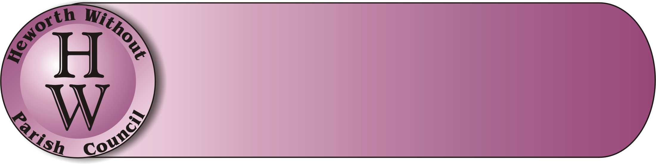
Heworth Without Parish Council
Gayle Enion-Farrington (Clerk to Parish Council)
1 Allington Drive, Appletree Village, Heworth, YORK, YO310NL
Tel: 07422961495
E-mail: clerk@heworthwithoutparishcouncil.gov.uk

Annual Parish Meeting
Monday 20th April 2026
6.30pm

Light refreshments will be served

An open forum to gather opinions in a public meeting on what residents wish / want from their Parish Council in the next 12-24 months. Also, an opportunity to find out more regarding the progress on HWPC’s Neighbourhood Plan.
Please come and share your views and ask any questions in an open format.

You are more than welcome to stay for our Ordinary Parish Council Meeting which commences at 7pm, following this meeting.

